STEPS TO HOST M3 WEB AT CLIENT PLACE
A. One-time prerequisites (per machine, run PowerShell as Administrator)
1. Enable IIS (this is a desktop OS, so use the optional-feature cmdlet, not Install-WindowsFeature which is Windows Server only):
Enable-WindowsOptionalFeature -Online -FeatureName IIS-WebServerRole, IIS-WebServer, IIS-CommonHttpFeatures, IIS-StaticContent, IIS-DefaultDocument, IIS-HttpErrors, IIS-HttpLogging, IIS-RequestFiltering, IIS-ManagementConsole -All
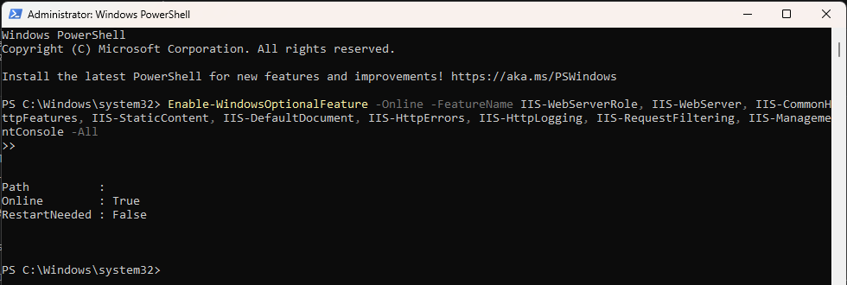
2. Install the ASP.NET Core Hosting Bundle matching this app's version (9.0) — Which can be found at :
https://learn.microsoft.com/en-us/aspnet/core/host-and-deploy/iis/hosting-bundle?view=aspnetcore-10.0
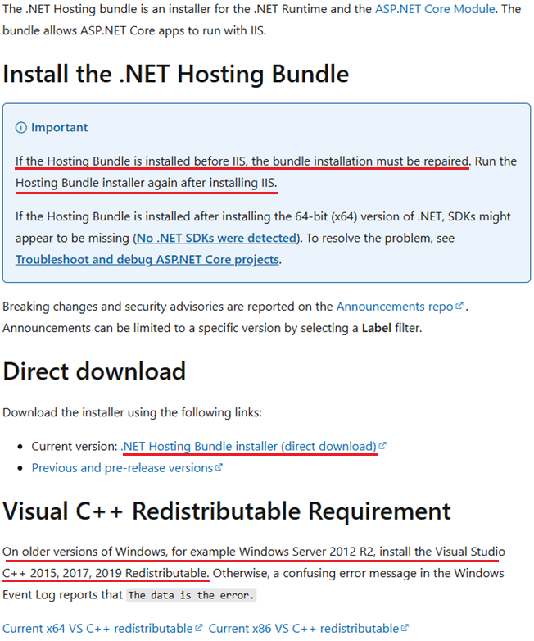
this is the piece that's actually missing. Download "ASP.NET Core Runtime 9.0.x — Hosting Bundle" (the Windows installer, not the SDK) from the official .NET downloads page, run it, then
3. Dot NET 9.0 Runtime (v9.0.19) - Windows x64 Installer!
https://dotnet.microsoft.com/en-us/download/dotnet/thank-you/runtime-9.0.19-windows-x64-installer?cid=getdotnetcore
restart IIS so it registers : (Or Restart The PC)
net stop was /y
net start w3svc

B. Get the published app onto the machine
At a real client site, nobody builds from source there — you just copy the already-published folder. From this PC that's E:\ABDM_Middleware\KrishnaABDM\bin\Release\net9.0\publish\ (already contains web.config, which is what tells IIS how to launch it). Copy that whole folder to, e.g., C:\inetpub\M3 on the target machine.
C. Create the IIS site
In IIS Manager (inetmgr):
- Application Pools → Add Application Pool → name M3AppPool, .NET CLR Version = "No Managed Code" (the app runs itself via the ASP.NET Core Module, IIS just proxies to it).
- Sites → Add Website → name M3, physical path = the copied folder, Press Select Button→ app pool = M3AppPool, binding = http, port 8090 (pick anything free — 80 is usually taken by the Default Web Site).
- Folder permissions: right-click the copied folder → Properties → Security → give IIS_IUSRS Read & Execute.
- It should auto-start. Test locally: http://localhost:8090/M3.
D. Open the firewall for the LAN
So the other workstations (All Lan PC) at that site can reach it:
New-NetFirewallRule -DisplayName "M3 Web" -Direction Inbound -Protocol TCP -LocalPort 8090 -Action Allow -Profile Private
E. Confirm from another PC on the LAN
http://<this-PC's-LAN-IP>:8090/M3 (get the IP via ipconfig).
F. Update the (HIMS / LIMS) launch URL
Once it's on IIS, every workstation's launch call changes from https://localhost:7145/... to http://<server-ip>:8090/m3/launch?....

